**CHATBOT DEPLOYMENT WITH IBM CLOUD WASTON ASSISTANT.**

**Introduction** :Chat bots are computer programs designed to simulate human conversation, and they play a significant role in automating customer support, handling routine queries, and improving user engagement. IBM Watson Assistant is a powerful platform that allows developers to create chat bots with natural language processing capabilities. Here's a brief introduction to chat bot development using IBM Watson Assistant.

INTRODUCTION TO WASTONX ASSISTANT - IBM DEVELOPER.

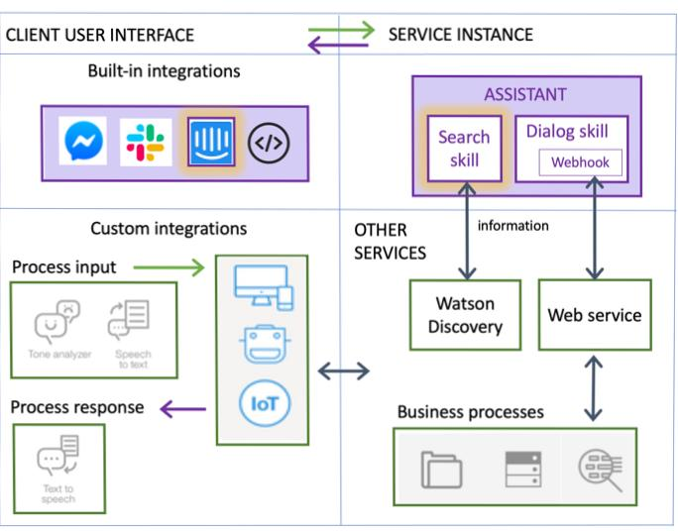The assistant receives user input and routes it to the dialog skill. The dialog skill interprets the user input further, then directs the flow of the conversation. The dialog gathers any information it needs to respond or perform a transaction on the user's behalf.

1.Understanding IBM Watson Assistant: IBM Watson Assistant is a service offered on IBM Cloud that enables the creation and deployment of chat bots and virtual agents. It leverages AI and machine learning to understand and respond to user inputs, making it an ideal choice for businesses and developers looking to enhance customer interactions.

2.key features:

#Natural Language Processing (NLP): Watson Assistant uses NLP to understand user intentions and provide contextually relevant responses.

#Multi-Channel Support: It can be integrated into various communication channels, including websites, messaging platforms, and mobile apps.

#Dialog Management: Developers can define dialog flows, intents, and entities to create dynamic and interactive chat bots.

#Training and Learning: Watson Assistant learns from user interactions, allowing it to improve over time.

3.Use cases:

#Customer Support: Chat bots can assist with common customer inquiries, reducing the load on human support agents.

#E-commerce: Chat bots can help users find products, make purchases, and track orders.

#Information Retrieval: They can provide information about services, products, or any topic of interest.

#Appointment Scheduling: Chat bots can schedule appointments and send reminders.

4.Development Process:

#Creating an Assistant: Start by defining an Assistant, which acts as the chat bot's core.

#Intents and Entities: Define user intents (what users want) and entities (specific information to extract).

#Dialog Design: Create dialog flows to determine how the chat bot responds to different inputs

#Integration: Connect the chat bot to your desired channels for user interaction.

5.Training and Testing: Train the chat bot by providing examples of user interactions. Test the chat bot extensively to refine its responses and improve accuracy.

6.Deployment: Once your chat bot is ready, deploy it to make it available to users through the integrated channels.

7.Continuous Improvement: Regularly analyse user interactions, gather feedback, and make necessary adjustments to enhance the chat bot's performance.

8.Training your chat bot:

# Providing example user inputs for training.

# Improving chat bot accuracy through machine learning.

9.Testing and Debugging:

#Testing your chat bot's responses. #Debugging common issues and refining dialog.

10.Security and compliance:

#Ensuring data privacy and security #Compliance with regulations (e.g., GDPR).

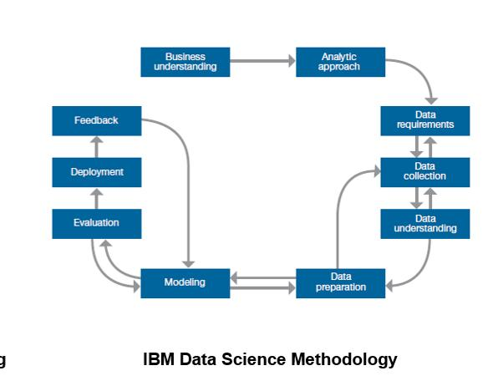

Purpose of chat bot with IBM:

Chat bots are conversational tools that perform routine tasks efficiently. People like them because they help them get through those tasks quickly so they can focus their attention on high-level, strategic, and engaging activities that require human capabilities that cannot be replicated by machines..

**The first task is to create an instance of Watson Assistant on IBM Cloud.**

1. Make sure that you are logged in to your IBM Cloud account..
2. Click catalog and then click Services > Watson > Assistant..
3. For the service name, type IT Support Conversation . Click Create. ...
4. Click Launch tool to open the Watson Assistant workspace.

Use of IBM waston today :

IBM Watson is employed in nearly every industry vertical, as well as in specialized application areas such as cybersecurity. This technology is often used by a company's data analytics team, but Watson has become so user friendly that it is also easily used by end users such as physicians or marketers.